Evaluation: Random Forest
Accuracy: 0.9684
Precision: 0.9684451397754552
Recall: 0.9684
F1 Score: 0.9683938192735794
Jaccard Index: 0.938982043784278
Matthews CorrCoef: 0.9605142157155897
Cohen’s Kappa: 0.9605
Specificity: 0.9921000000000001
AUC: 0.9990135
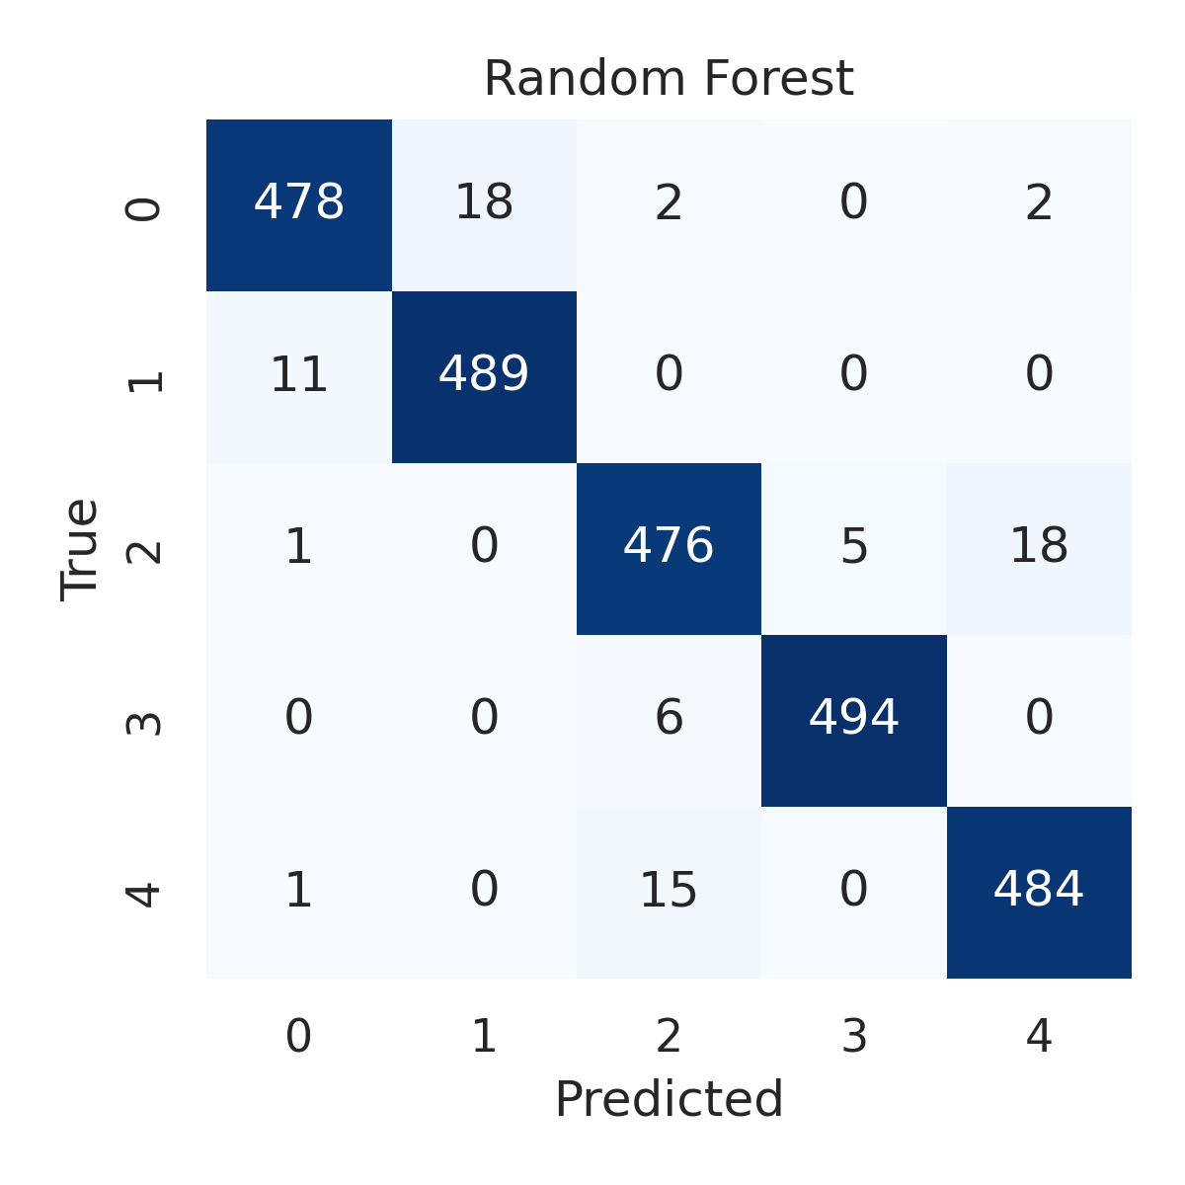

Combined ROC Curves
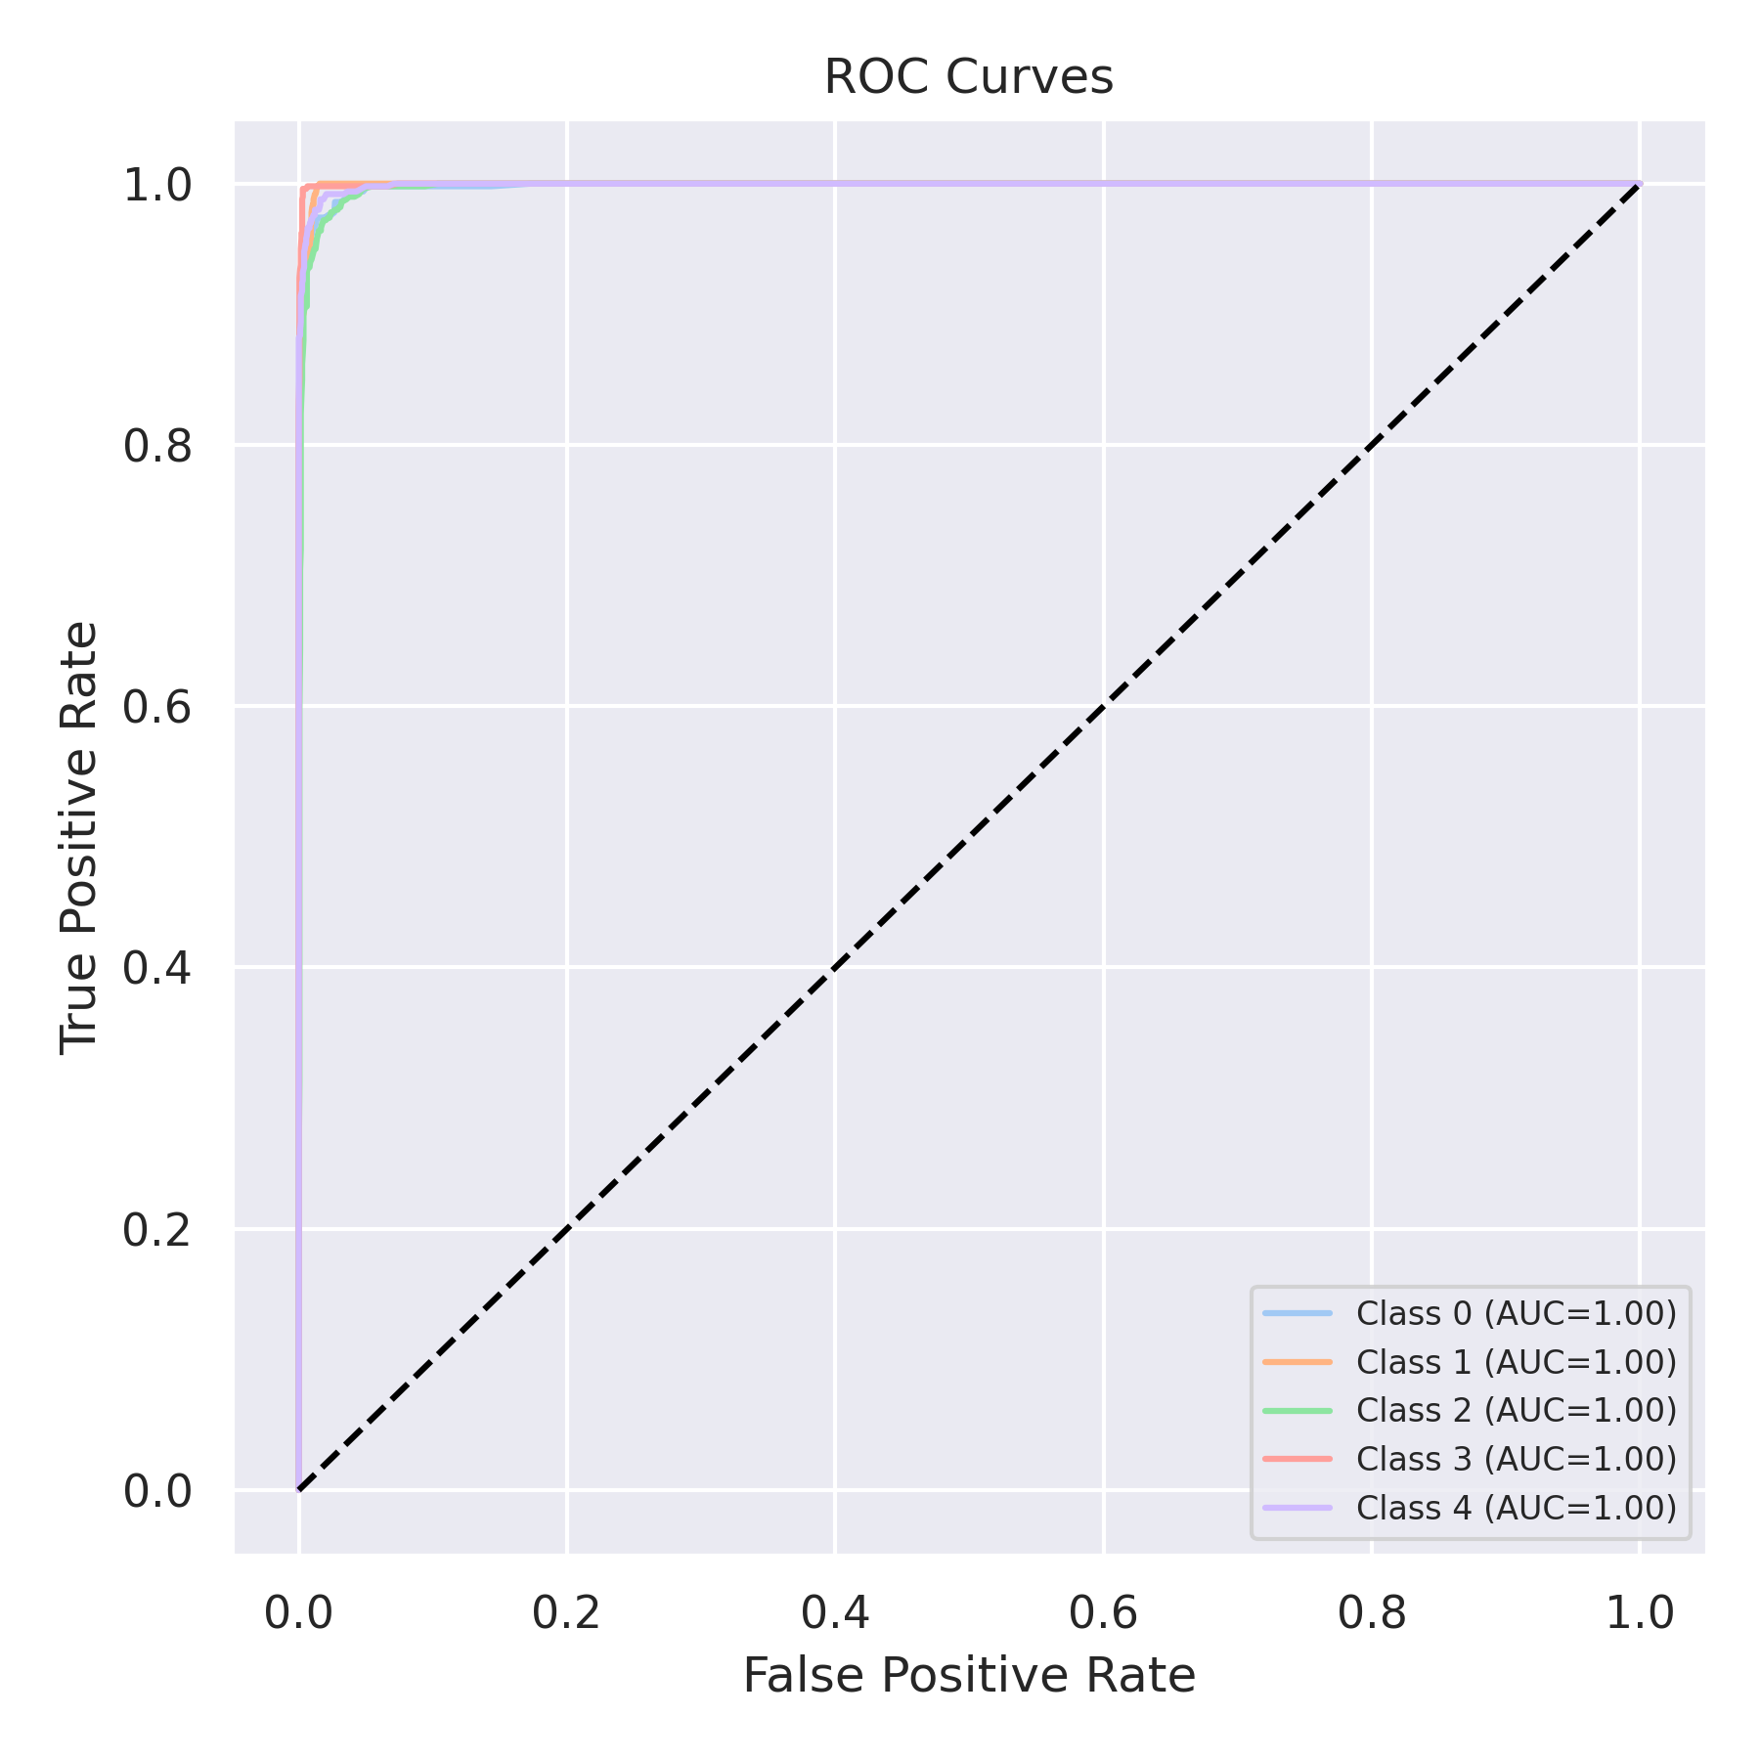

Evaluation: K-Nearest Neighbors
Accuracy: 0.8928
Precision: 0.8957967119235245
Recall: 0.8928
F1 Score: 0.8919704846051776
Jaccard Index: 0.8067843190333329
Matthews CorrCoef: 0.8670897495184131
Cohen’s Kappa: 0.866
Specificity: 0.9732
AUC: 0.9773679999999999
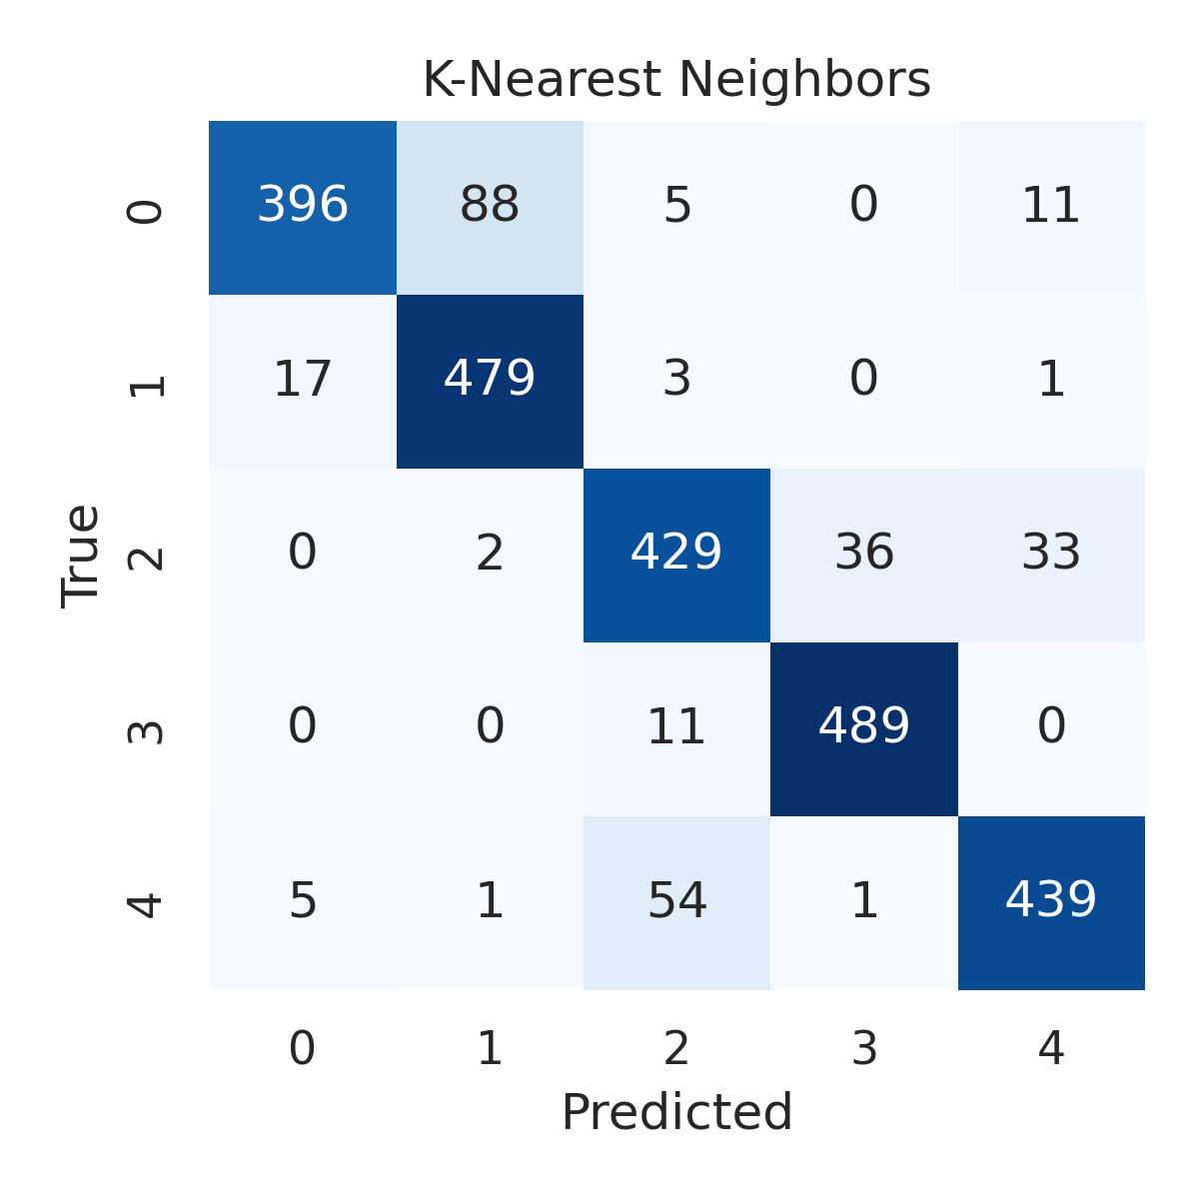

Combined ROC Curves
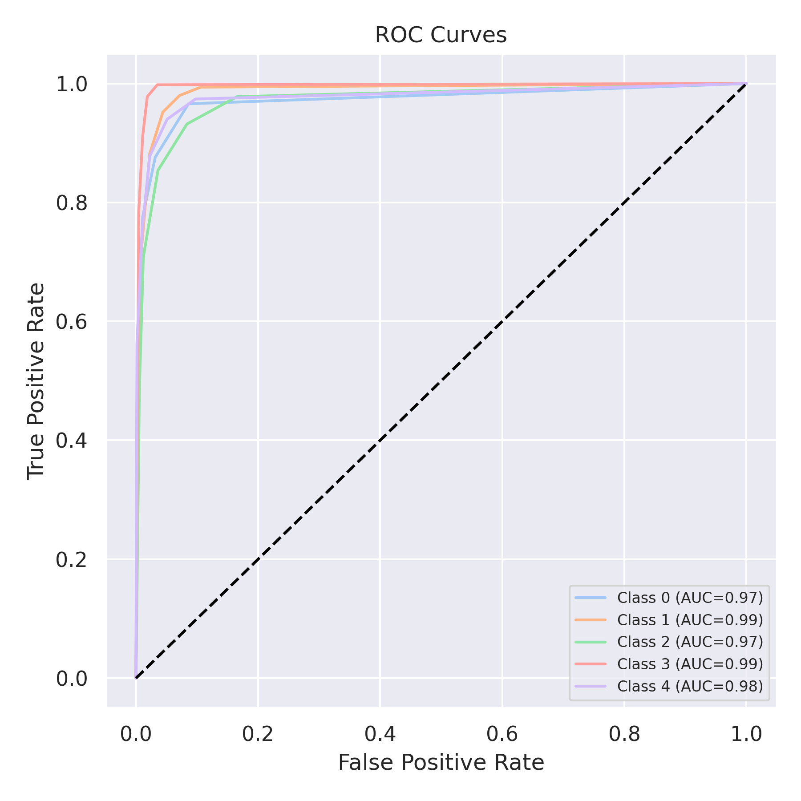

Evaluation: Decision Tree
Accuracy: 0.96
Precision: 0.9601165764755131
Recall: 0.96
F1 Score: 0.9600338424696414
Jaccard Index: 0.9235736297092493
Matthews CorrCoef: 0.9500123502408303
Cohen’s Kappa: 0.95
Specificity: 0.99
AUC: 0.9712500000000001
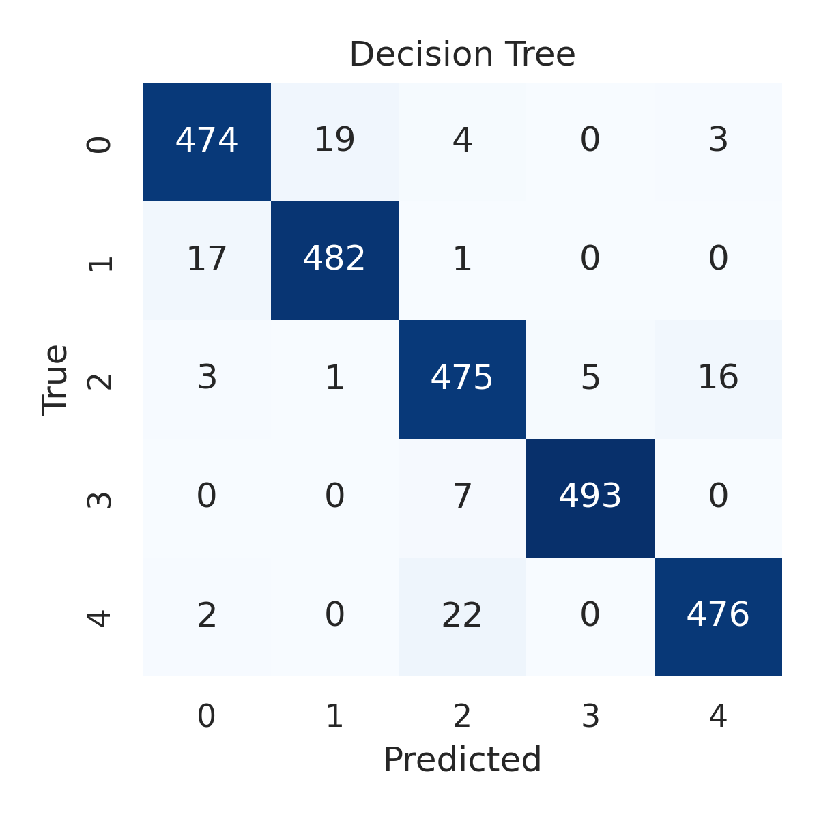

Combined ROC Curves
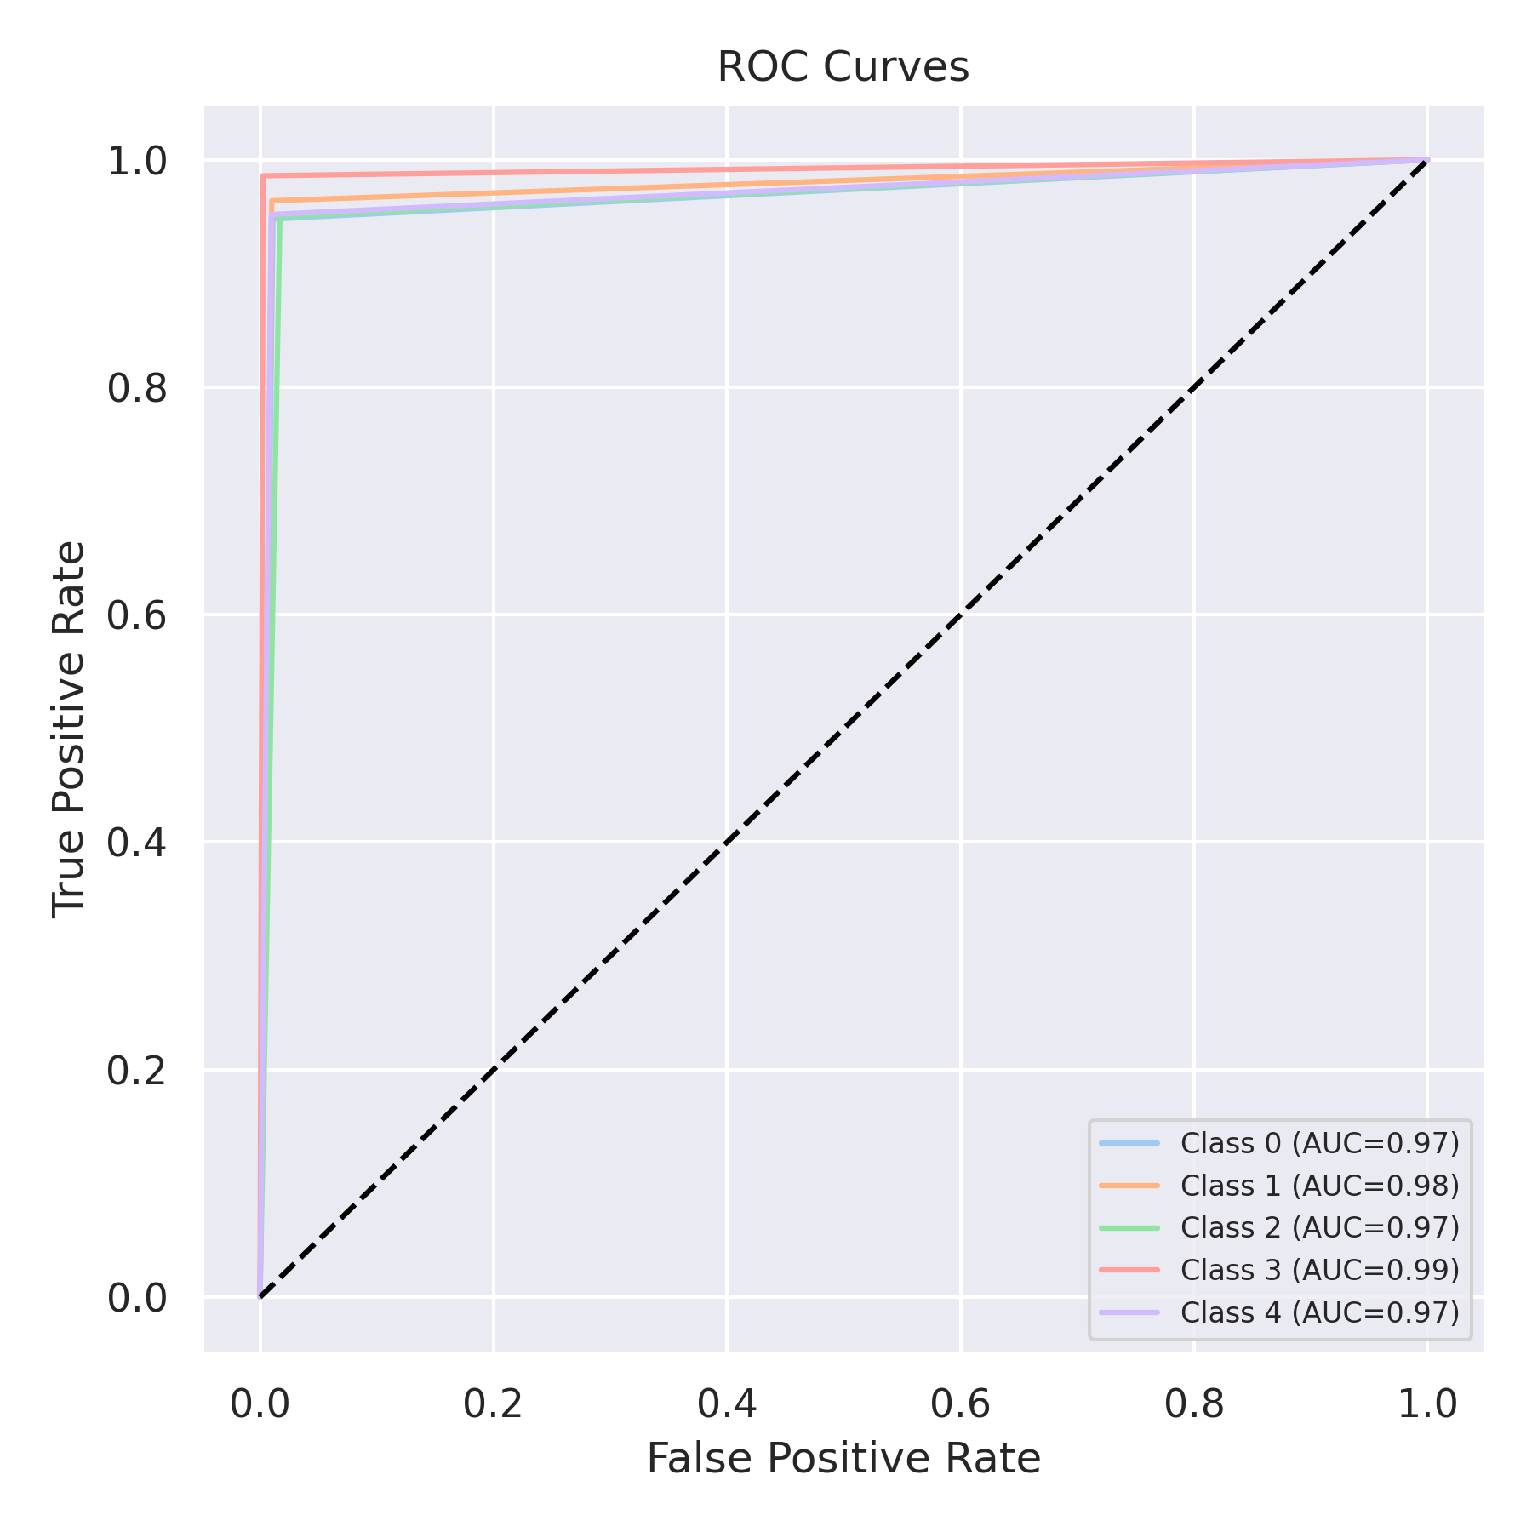

Evaluation: Extra Trees
Accuracy: 0.9732
Precision: 0.9732321783013987
Recall: 0.9732
F1 Score: 0.9731851470224883
Jaccard Index: 0.9480740329871533
Matthews CorrCoef: 0.9665152710619251
Cohen’s Kappa: 0.9665
Specificity: 0.9933
AUC: 0.99923
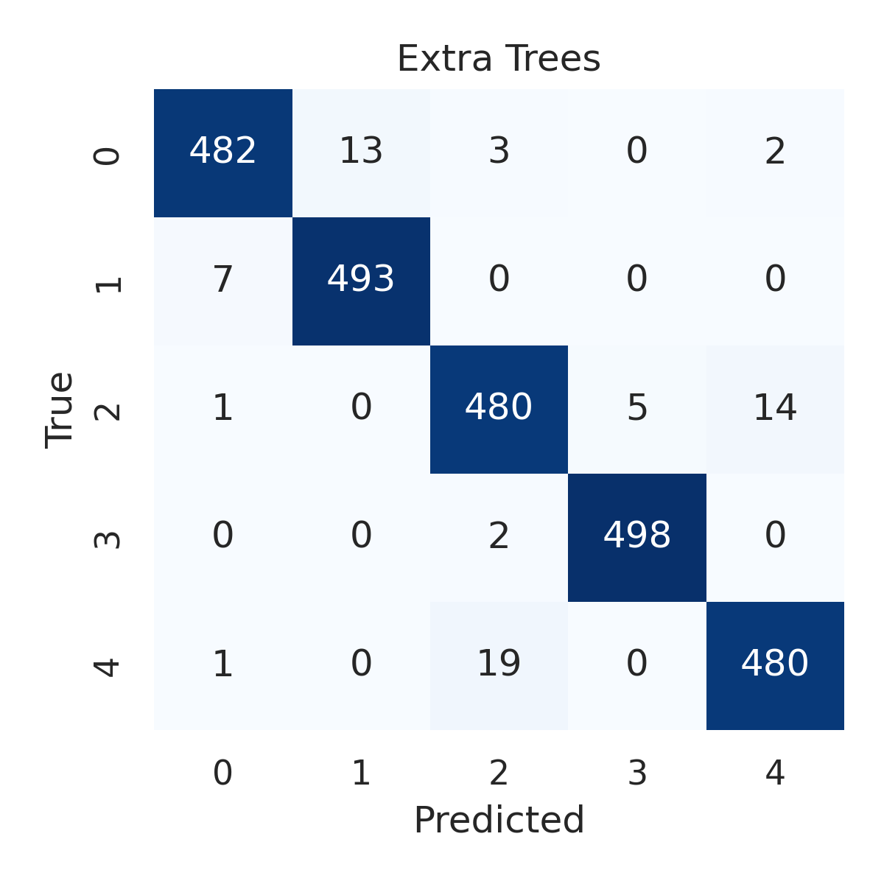

Combined ROC Curves
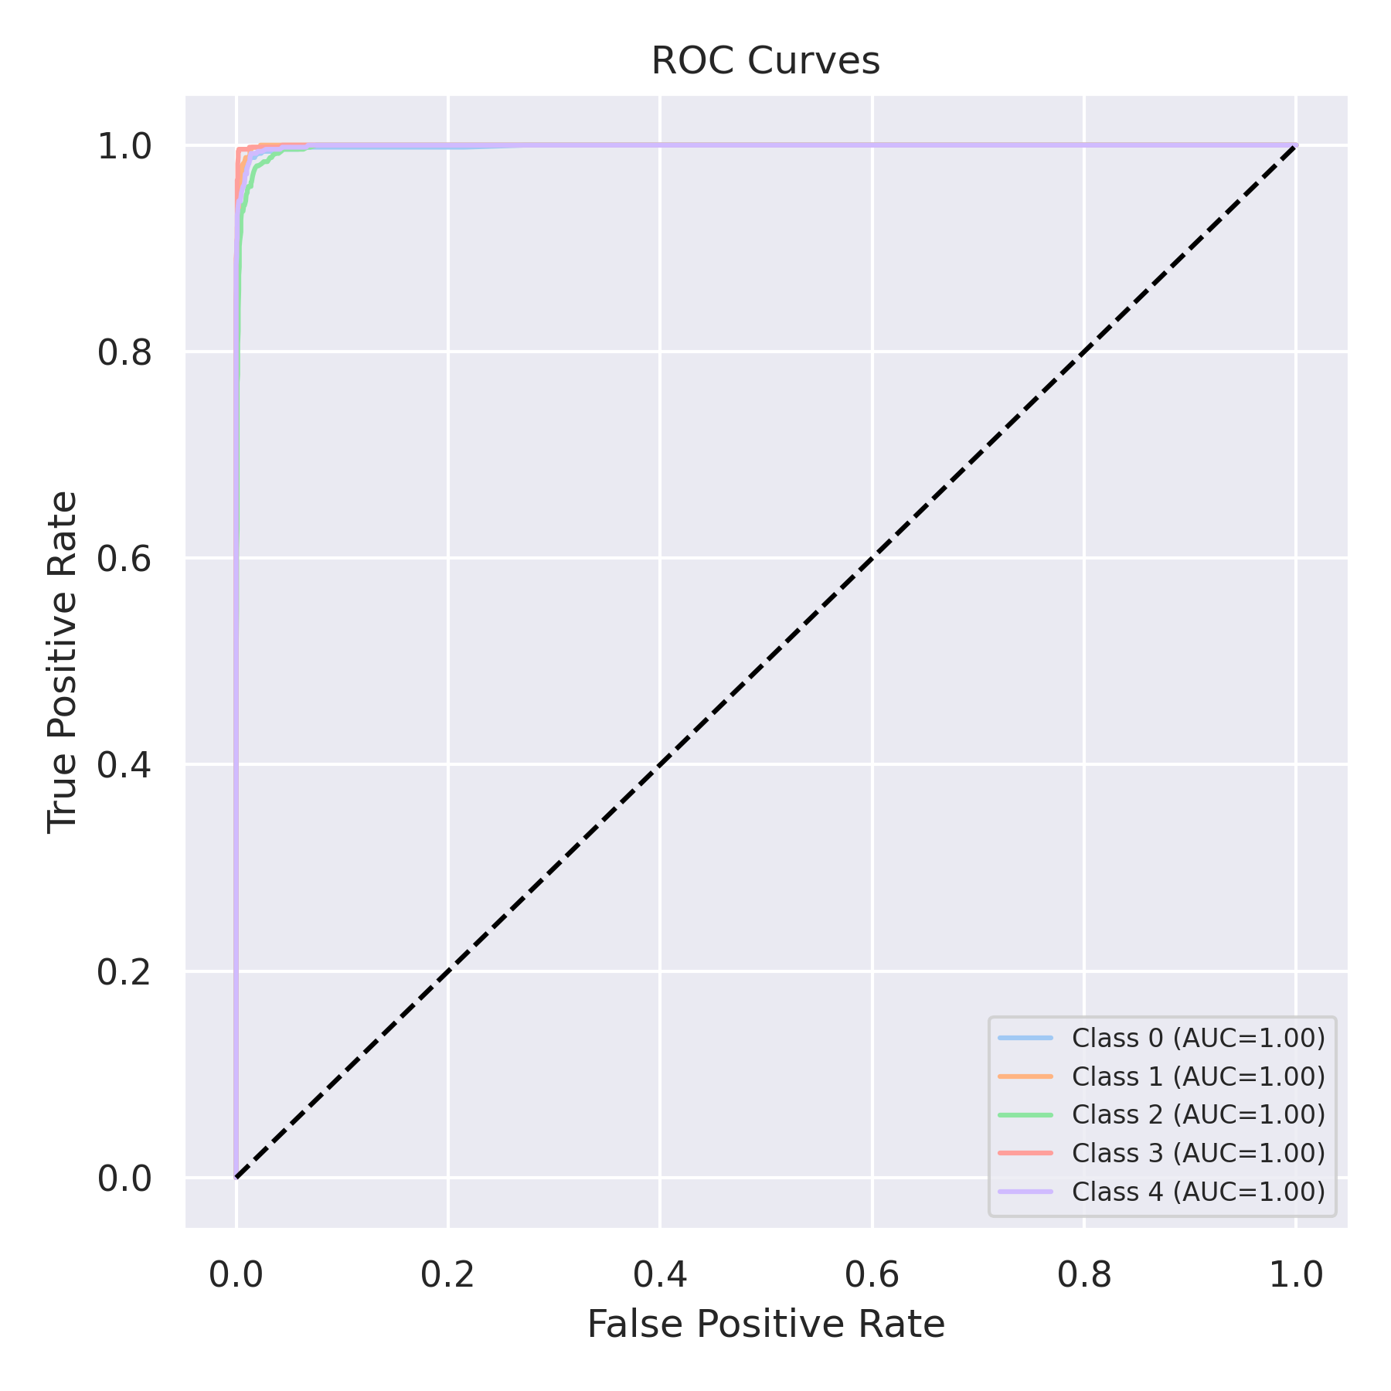

Evaluation: Bagging Classifier
Accuracy: 0.97
Precision: 0.9700437496177019
Recall: 0.97
F1 Score: 0.9700153370035001
Jaccard Index: 0.9420418585822657
Matthews CorrCoef: 0.9625032725166898
Cohen’s Kappa: 0.9625
Specificity: 0.9925
AUC: 0.999186
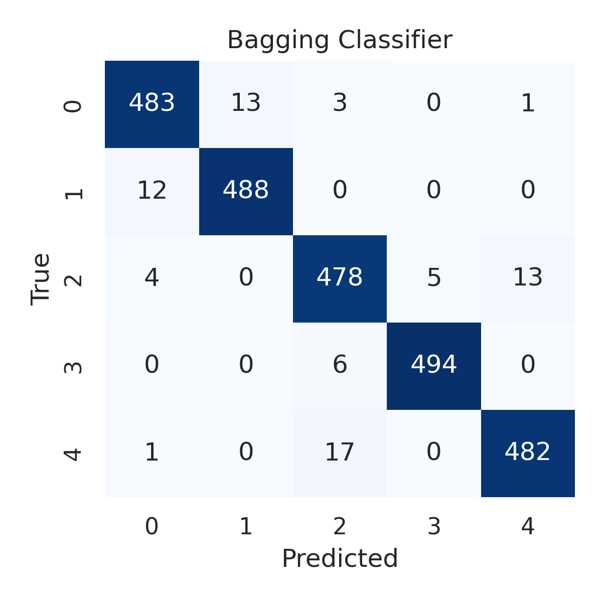

Combined ROC Curves
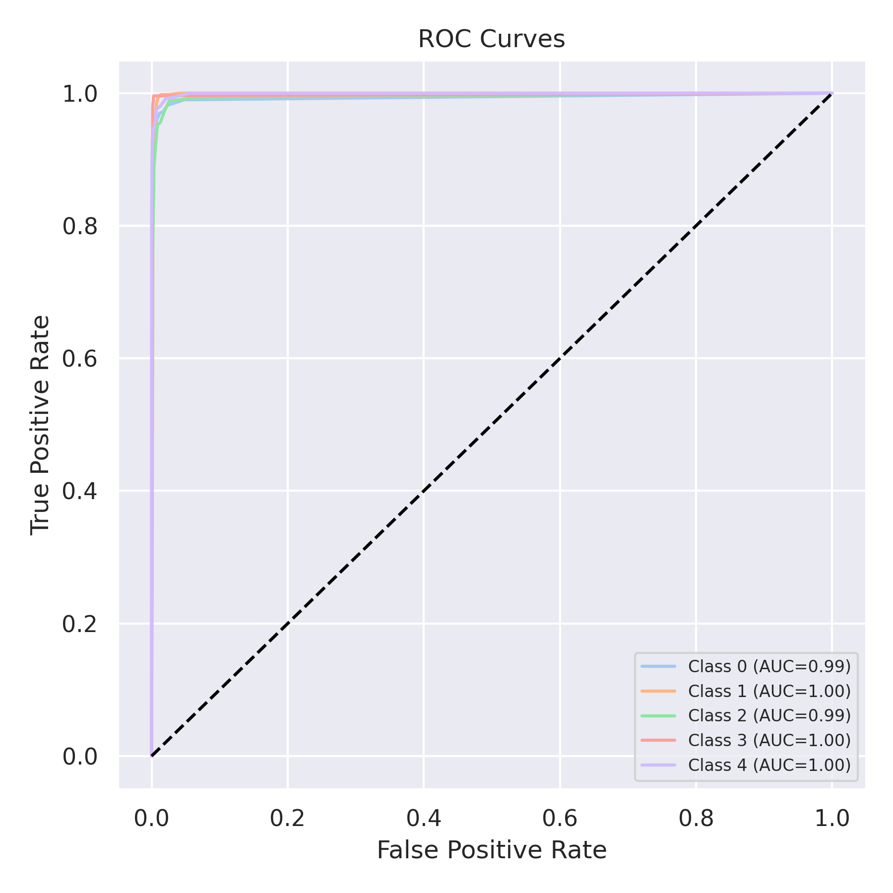

Evaluation: XGBoost
Accuracy: 0.9832
Precision: 0.9832654409464127
Recall: 0.9832
F1 Score: 0.983199320952865
Jaccard Index: 0.9670437995862255
Matthews CorrCoef: 0.9790166434244086
Cohen’s Kappa: 0.979
Specificity: 0.9958
AUC: 0.9996440000000001
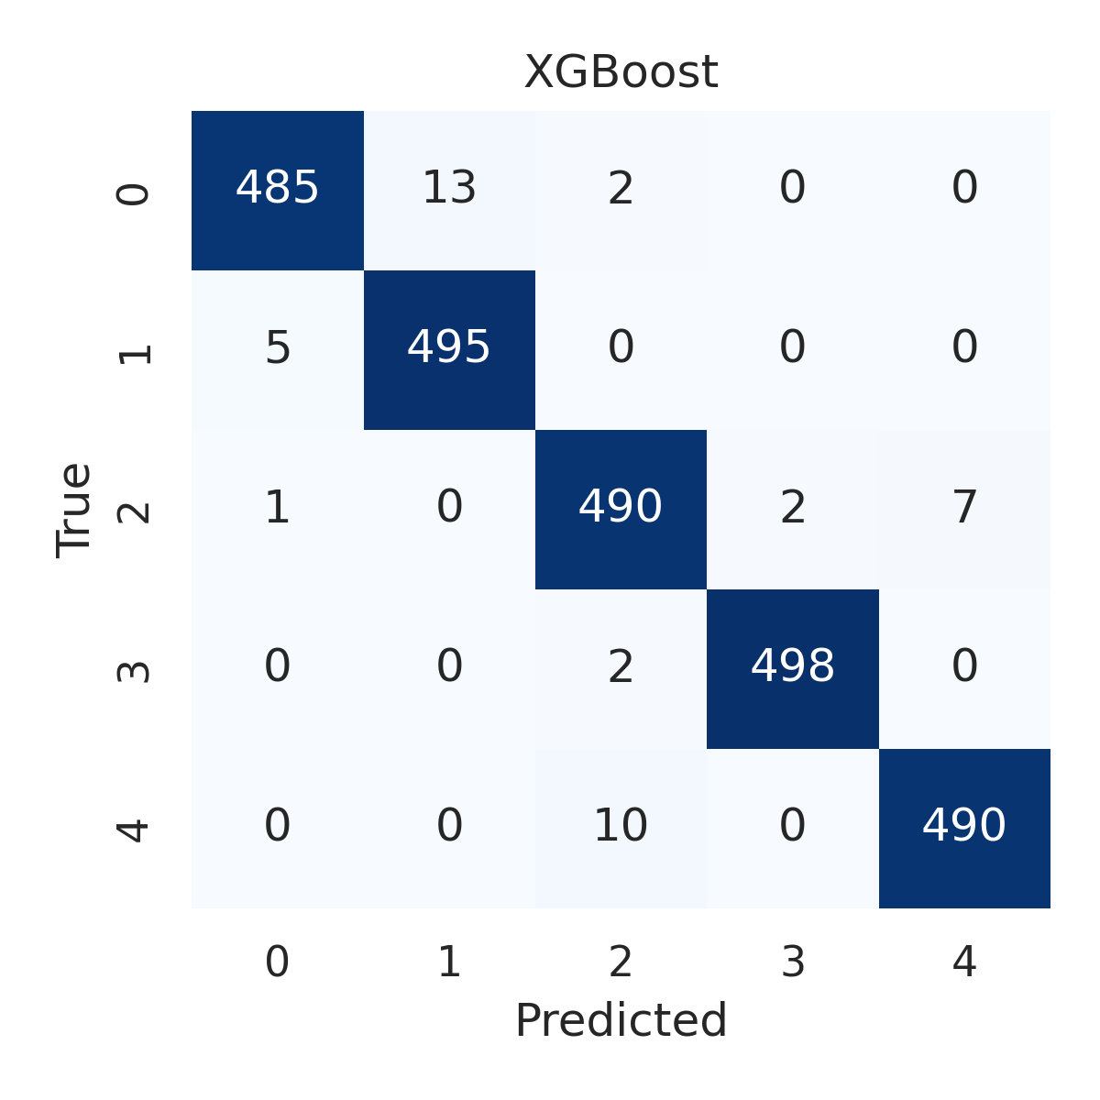

Combined ROC Curves
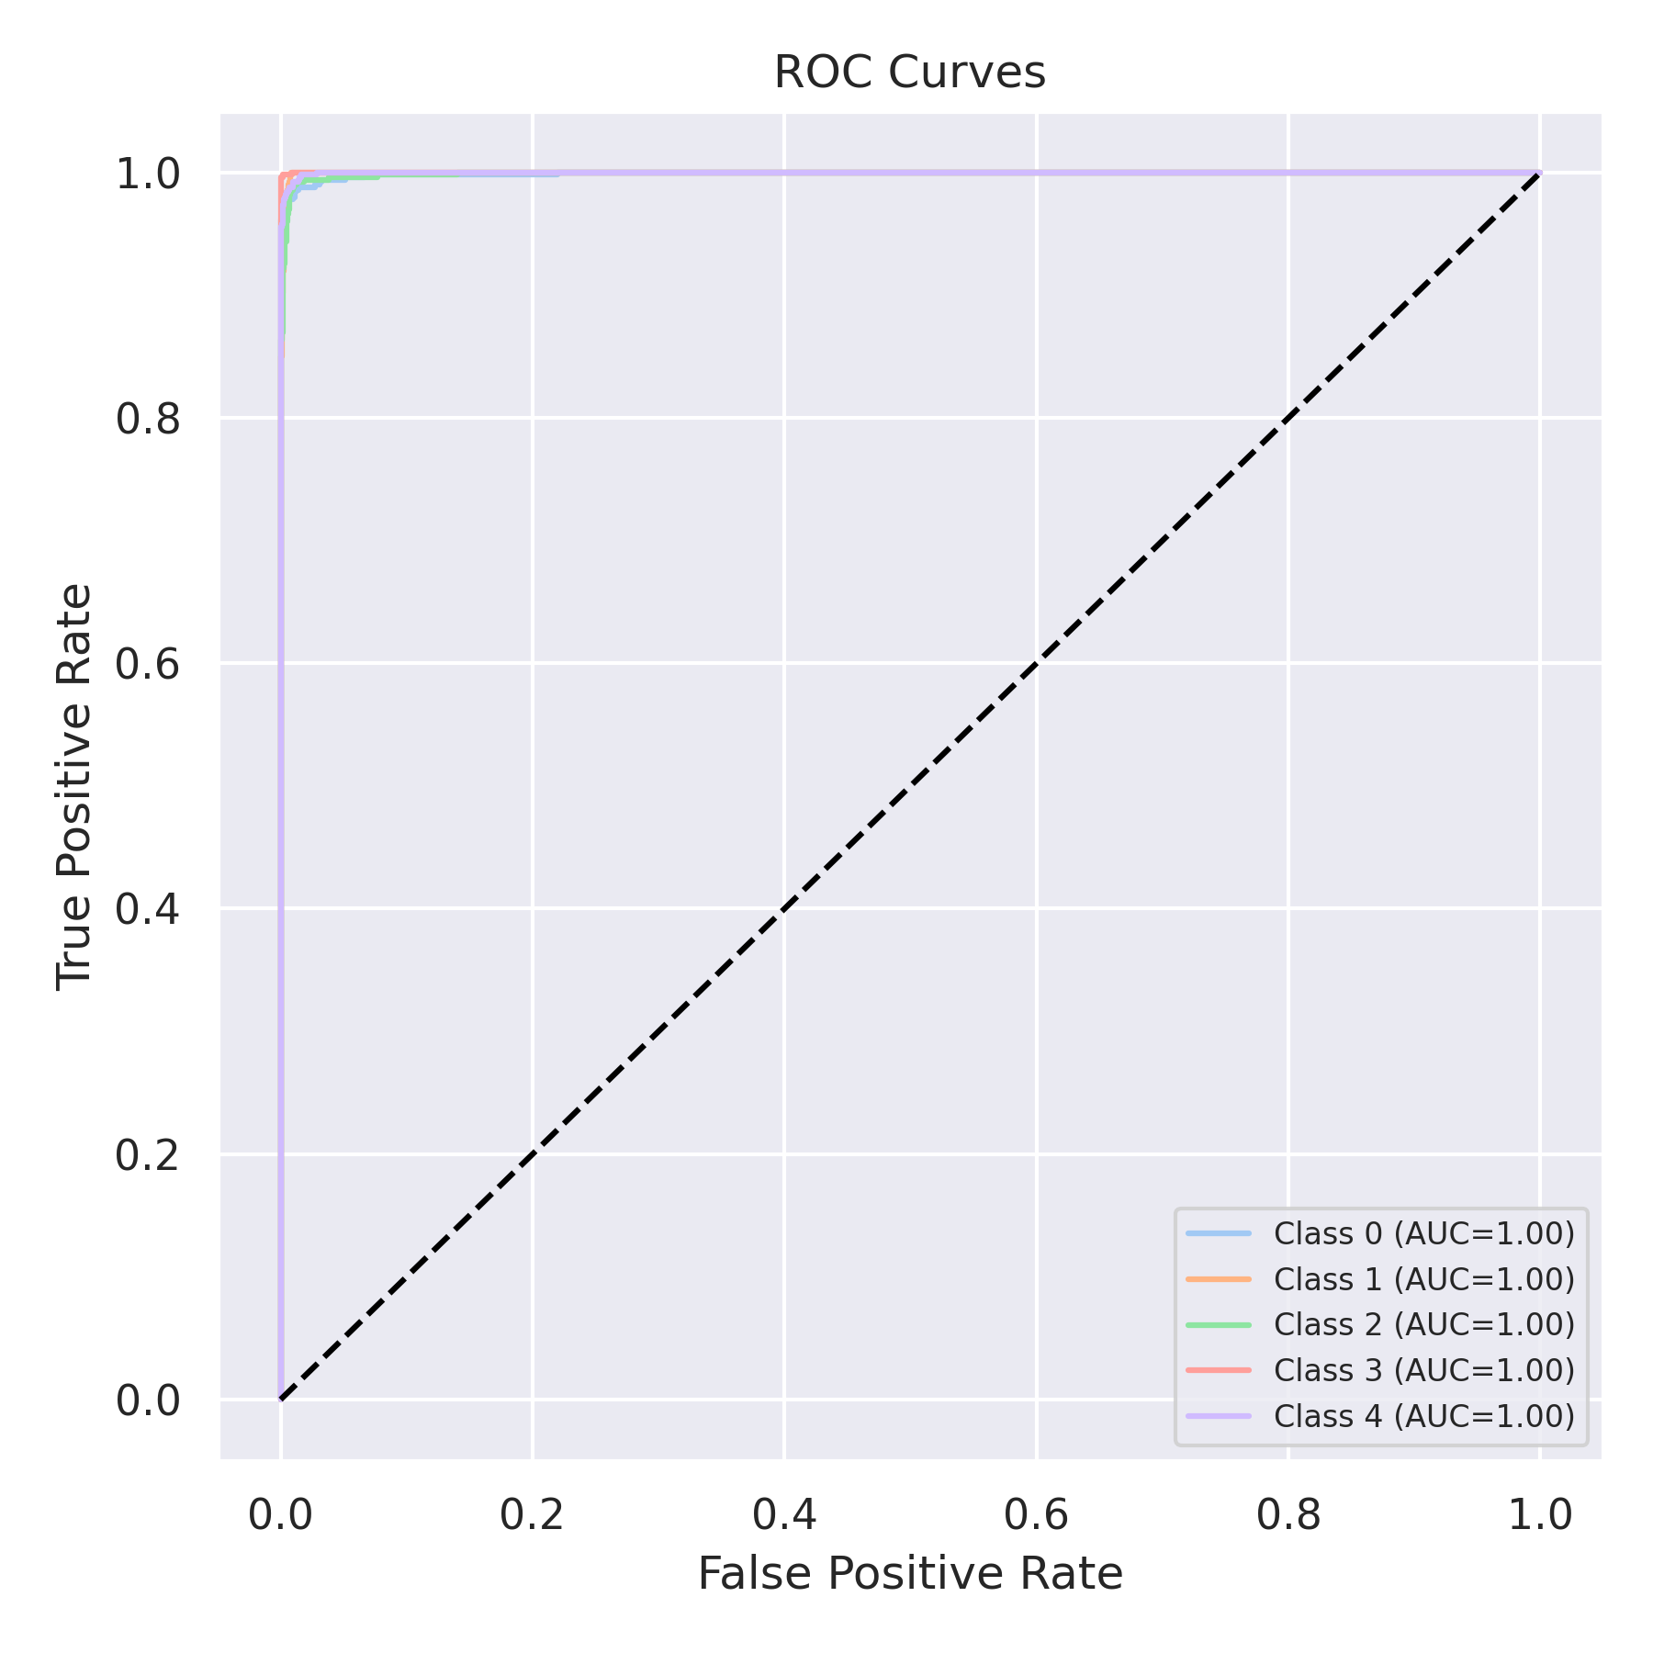

Evaluation: LightGBM
Accuracy: 0.9832
Precision: 0.9832152852606312
Recall: 0.9832
F1 Score: 0.9831884413162676
Jaccard Index: 0.967026386022282
Matthews CorrCoef: 0.9790095943410371
Cohen’s Kappa: 0.979
Specificity: 0.9958
AUC: 0.999735
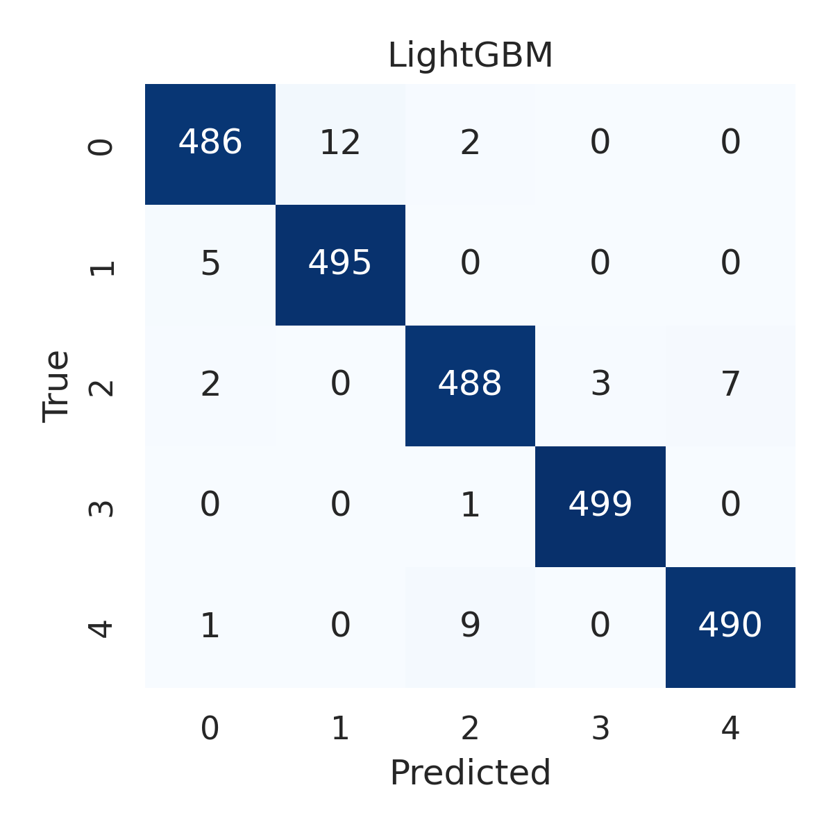

Combined ROC Curves
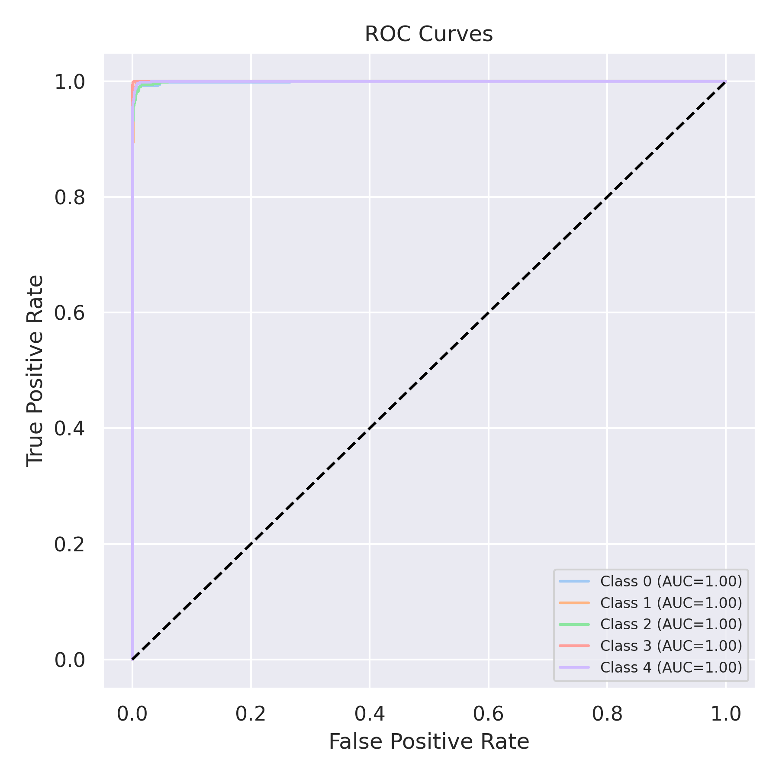

Evaluation: CatBoost
Accuracy: 0.2
Precision: 0.04
Recall: 0.2
F1 Score: 0.06666666666666667
Jaccard Index: 0.04
Matthews CorrCoef: 0.0
Cohen’s Kappa: 0.0
Specificity: 0.8
AUC: 0.999649
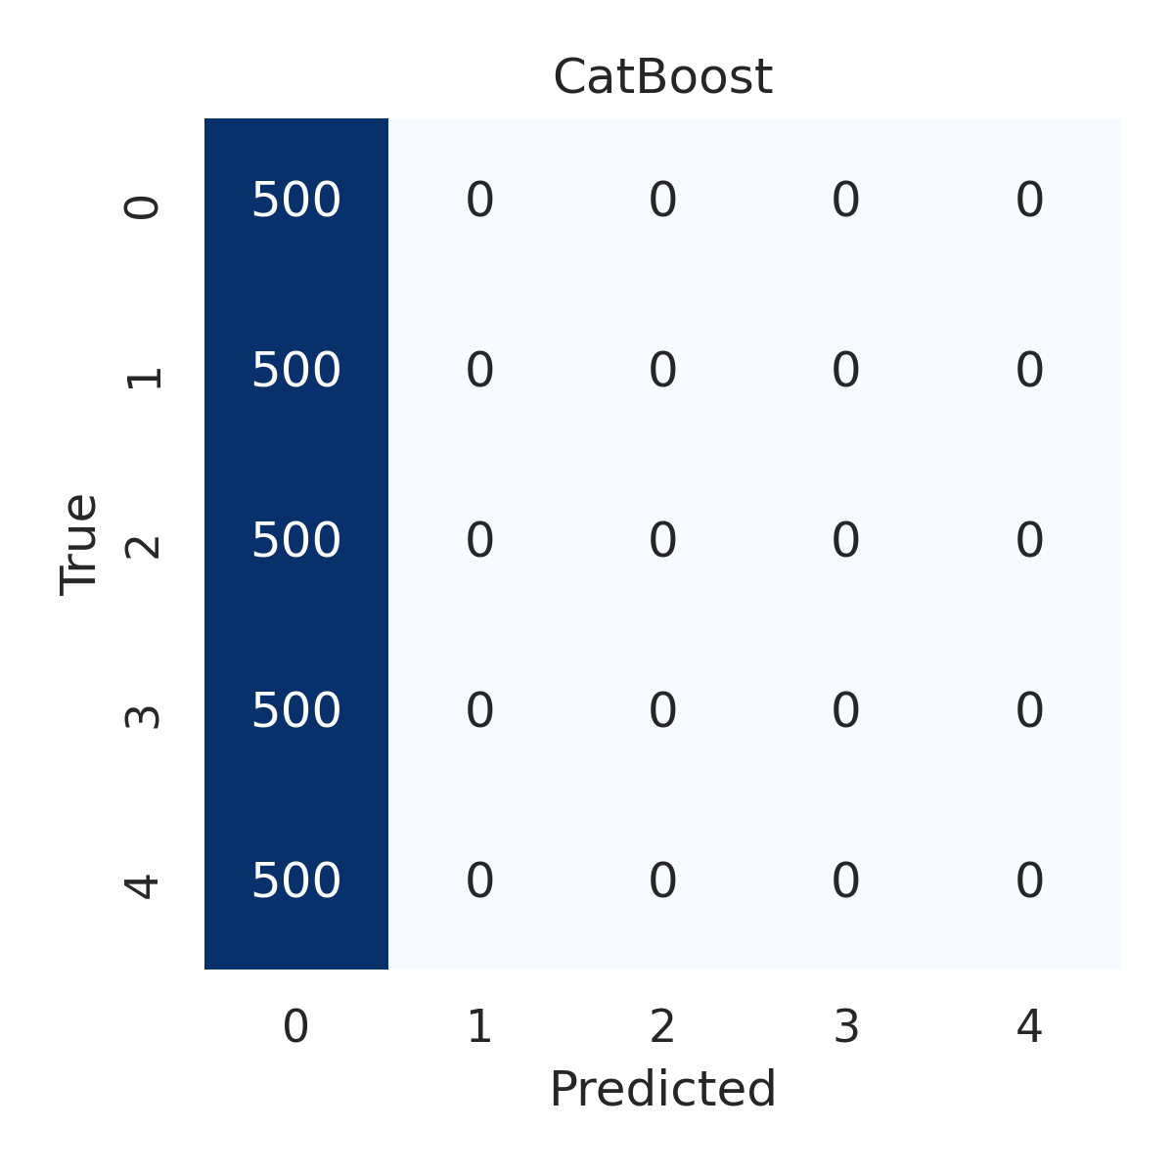

Combined ROC Curves
